SET 6 – Product Sales Analysis

1. Grouped Bar Chart – First Quarter Sales
Aim:
To create a grouped bar chart comparing the January, February, and March sales of each product.
Code:
product <- c("Product A", "Product B", "Product C")

sales <- matrix(c(2000, 2200, 2400,
1500, 1800, 1600,
1200, 1400, 1100),
nrow = 3, byrow = TRUE)

colnames(sales) <- c("January", "February", "March")
rownames(sales) <- product

barplot(t(sales),
beside = TRUE,
legend.text = TRUE,
main = "Monthly Product Sales",
xlab = "Product",
ylab = "Sales")

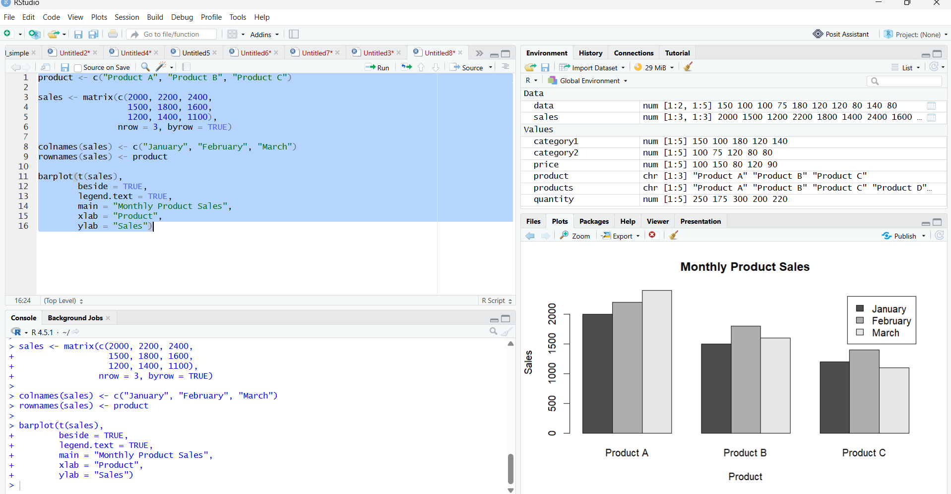

2. Stacked Area Chart – Overall Sales Trend
Aim:
To create a stacked area chart representing the sales trend of all products over three months.
Code:
month <- c("January", "February", "March")

productA <- c(2000, 2200, 2400)
productB <- c(1500, 1800, 1600)
productC <- c(1200, 1400, 1100)

data <- rbind(productA, productB, productC)

matplot(1:3, t(data),
type = "o",
lty = 1,
xaxt = "n",
main = "Product Sales Trend",
xlab = "Month",
ylab = "Sales")

axis(1, at = 1:3, labels = month)

legend("topleft",
legend = c("Product A", "Product B", "Product C"),
lty = 1)

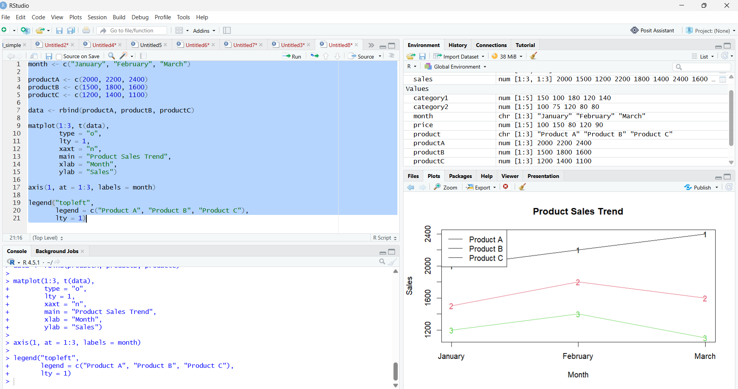

3. Table – Monthly Sales Data
Aim:
To create a table displaying the monthly sales data for each product.
Code:
sales_data <- data.frame(
Product = c("Product A", "Product B", "Product C"),
January = c(2000, 1500, 1200),
February = c(2200, 1800, 1400),
March = c(2400, 1600, 1100)
)

print(sales_data)

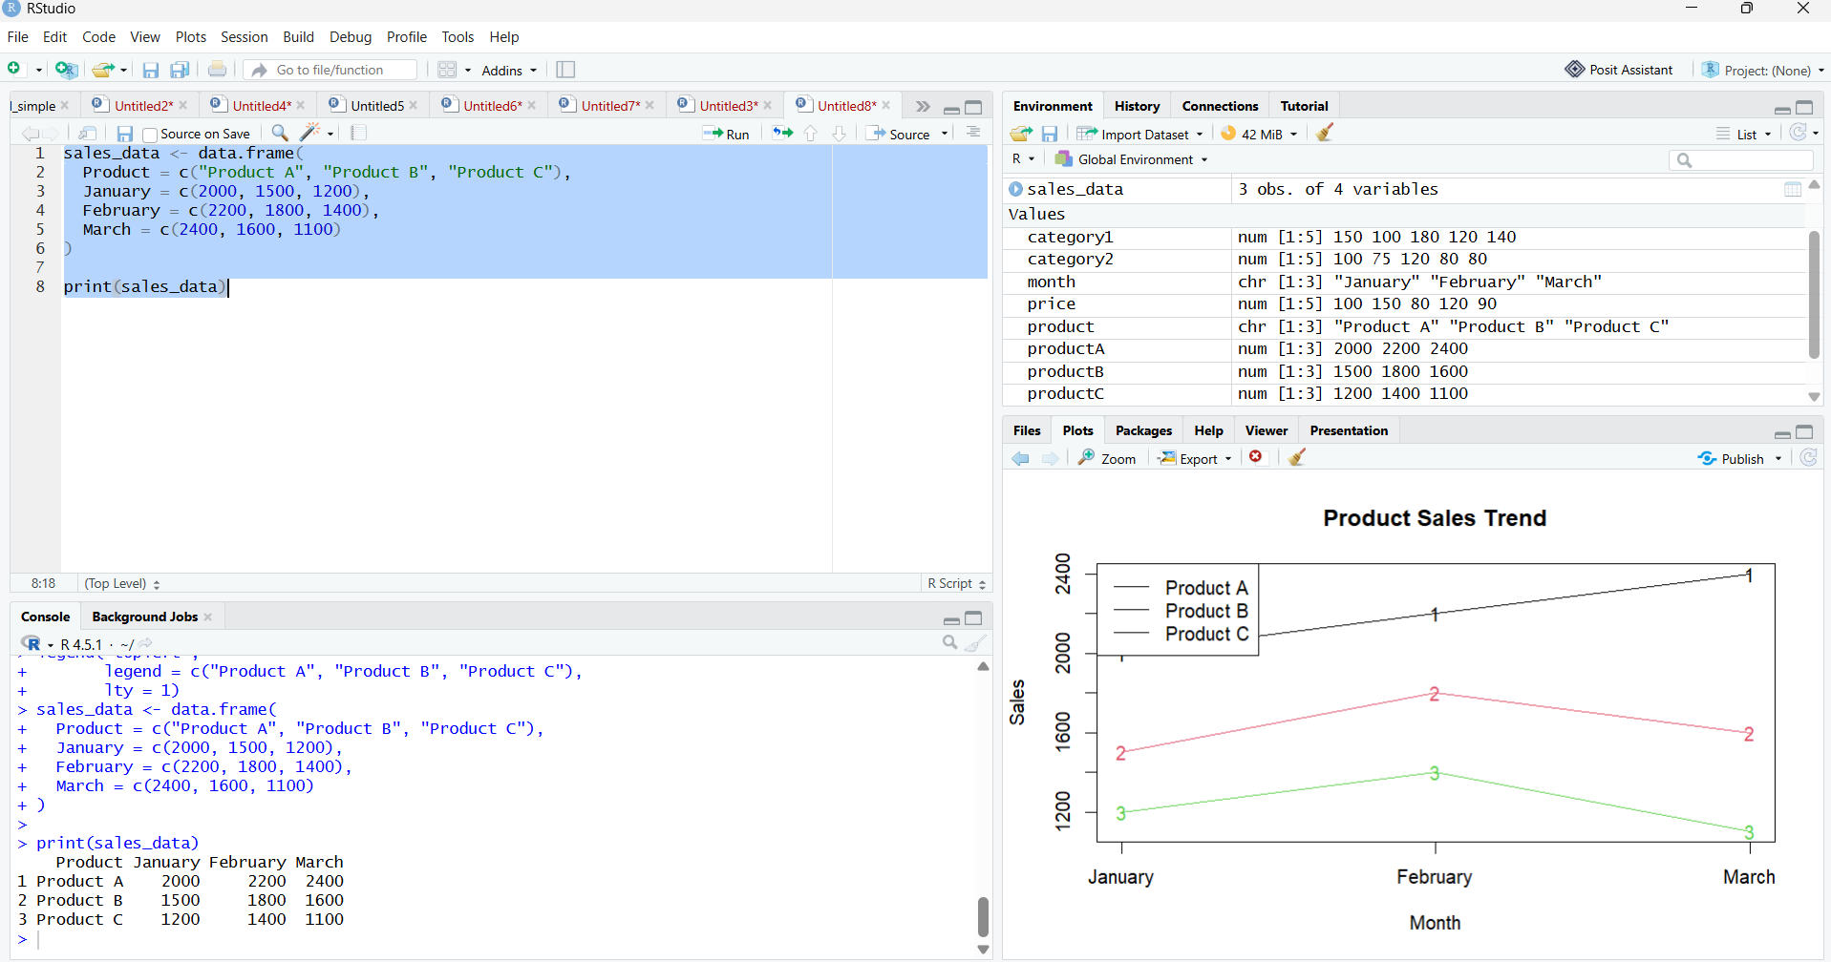

4. Develop a Tableau dashboard combining the grouped bar chart, stacked area chart, and the table for interactive exploration of sales data.
